|  |  |  |  |  |  |  |
| --- | --- | --- | --- | --- | --- | --- |
| |  |  |  |  | | --- | --- | --- | --- | |  | | **MINISTRY OF EDUCATION AND TRAINING** | | | **FPT UNIVERSITY** | | |
| Capstone Project Document |
| Family Album Sharing System |
| |  |  |  |  |  |  |  |  |  |  |  | | --- | --- | --- | --- | --- | --- | --- | --- | --- | --- | --- | | |  |  | | --- | --- | | **Group 12** | | | **Group member** | Huỳnh Trần Minh Nhựt – Leader – SE60936  Tô Đình Tân – Member – SE60926  Trần Lê Tuấn – Member – 60350 | | **Supervisor** | Nguyễn Huy Hùng | | **Ext. Supervisor** | N/A | | **Capstone Project code** | FAMSAM | | |
| – Ho Chi Minh City, September 2014 – |

Table of Contents

4. Software Design Description (SDD) 3

4.2 Design Overview 3

4.3 System Architectural Design 3

4.3.1 Choice of System Architecture 3

4.3.2 Discussion of Alternative Designs 4

4.3.3 Description of System Interface 4

4.4 Package Diagram 4

4.4.1 Web Client Package Diagram 4

4.4.2 Server and Background Services Package Diagram 5

4.5 Class Diagram 6

4.5.1 Manage Story 6

4.5.2 Manage Album 7

4.5.3 Notification 7

4.6 Sequence Diagram 8

4.6.1 Login 8

4.6.2 Server Authorize 9

4.6.3 Create Story 10

4.6.4 Invite a Person to Family 10

4.6.5 Upload Photo 12

4.6.6 Notification 13

4.6.7 Other 14

4.7 User Interface Design 14

# Software Design Description (SDD)

## Design Overview

## System Architectural Design

### Choice of System Architecture

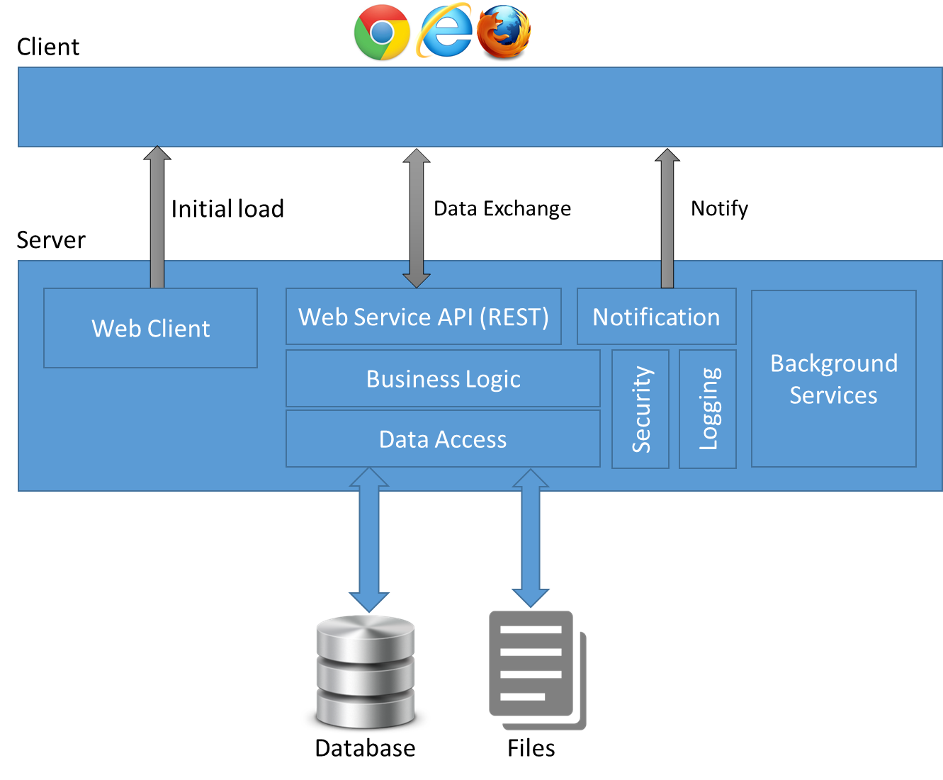

Figure 1. FAMSAM system architecture

* The aim of this architecture is to build single-page application.
* Client is presentation layer. It major responsible for UI rendering, client side routing, dynamic view, server data access. Client’s contents are first in server, once it initial loaded to client, no further browser refresh is needed, client-server transaction is data-only (using JSON).
* Server
  + Provide web service API for client to exchange data with security.
  + Have function of notifying to client.
  + Do the business logic.
  + Data gathering and accessing.
* The background services contain services handled behind client-server transaction to improve system performance.

### Discussion of Alternative Designs

N/A

### Description of System Interface

N/A

## Package Diagram

### Web Client Package Diagram

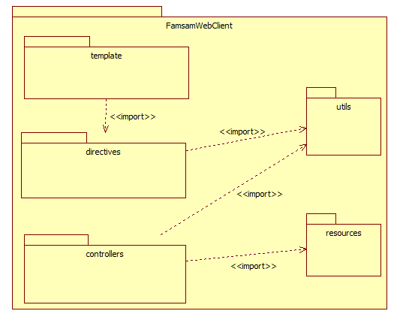

Figure 2 – Package diagram for Web Client implementation

* “template”: HTML, CSS for states of views (a state of view contains three major properties: URL to access state, template and controller).
* “directives”: define custom HTML elements or attributes which make richer template view.
* “controllers”: contains controllers, to define code behind for each state of views.
* “resources”: contains all the elements by which controllers can communicate with server.
* “utils”: code of utilities.

### Server and Background Services Package Diagram

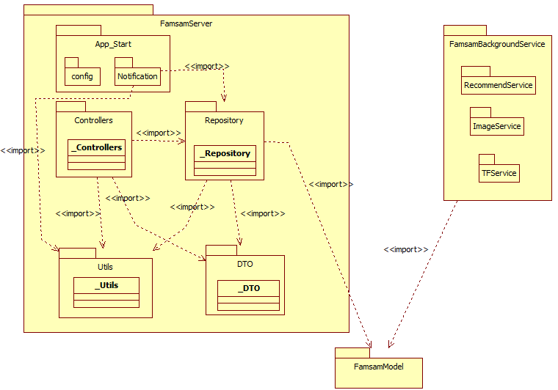

Figure 3 - Package diagram for FAMSAM Server and Background Services implementation

* FamsamServer:
  + App_Start:
    - Server configurations.
    - Notification process.
  + Controllers: contains ApiControllers of .Net Web API.
  + Repository: has responsible for access to model and prepare DTOs using Entity Framework.
  + DTO: contains data transfer objects which are used for client-server data exchange.
  + Utils: code for utilities.
  + All classes in each sub-packages of FamsamServer have package name as suffix.
* FamsamBackgroudService: contains background services.
* FamsamModel: contains entities from Entity Framework Code-First.

## Class Diagram

### Manage Story

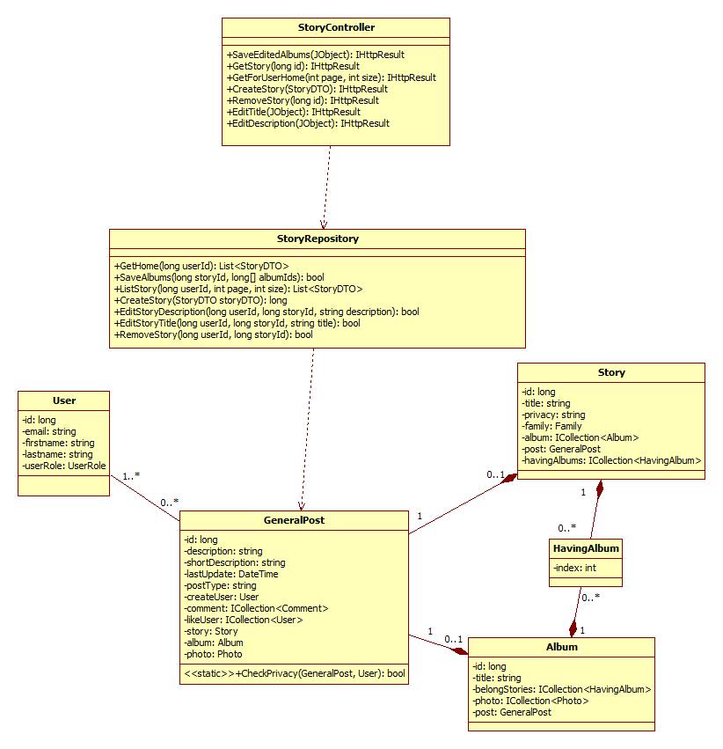

Figure 4 - Manage Story Class Diagram

### Manage Album

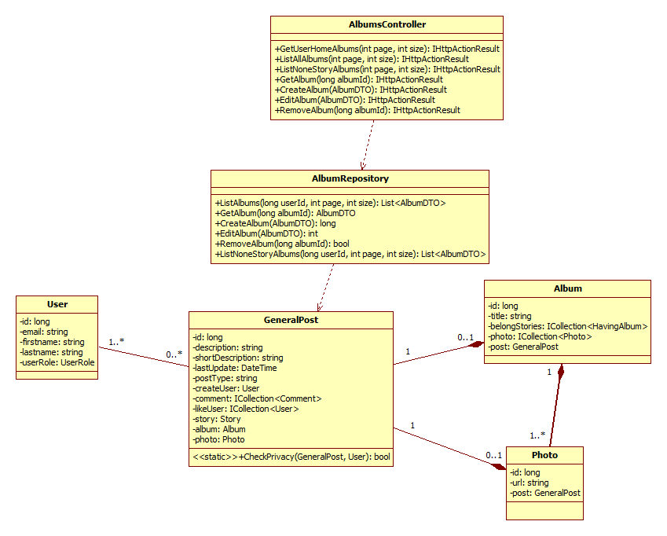

Figure 5 - Manage Album Class Diagram

### Family

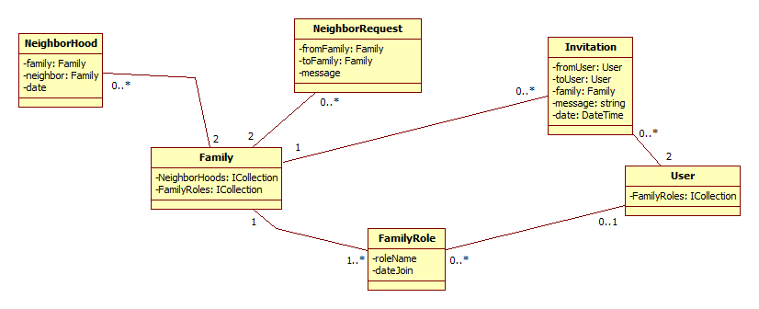

Figure 6 - Family Invite and Request Neighbor Class Diagram

### Notification

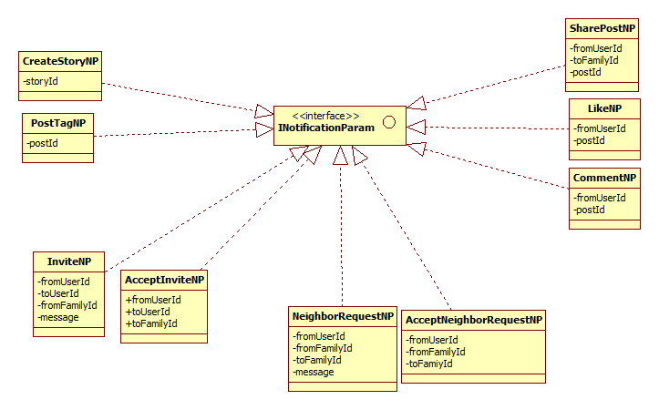

Figure 7 - Notification Class Diagram

## Sequence Diagram

### Login

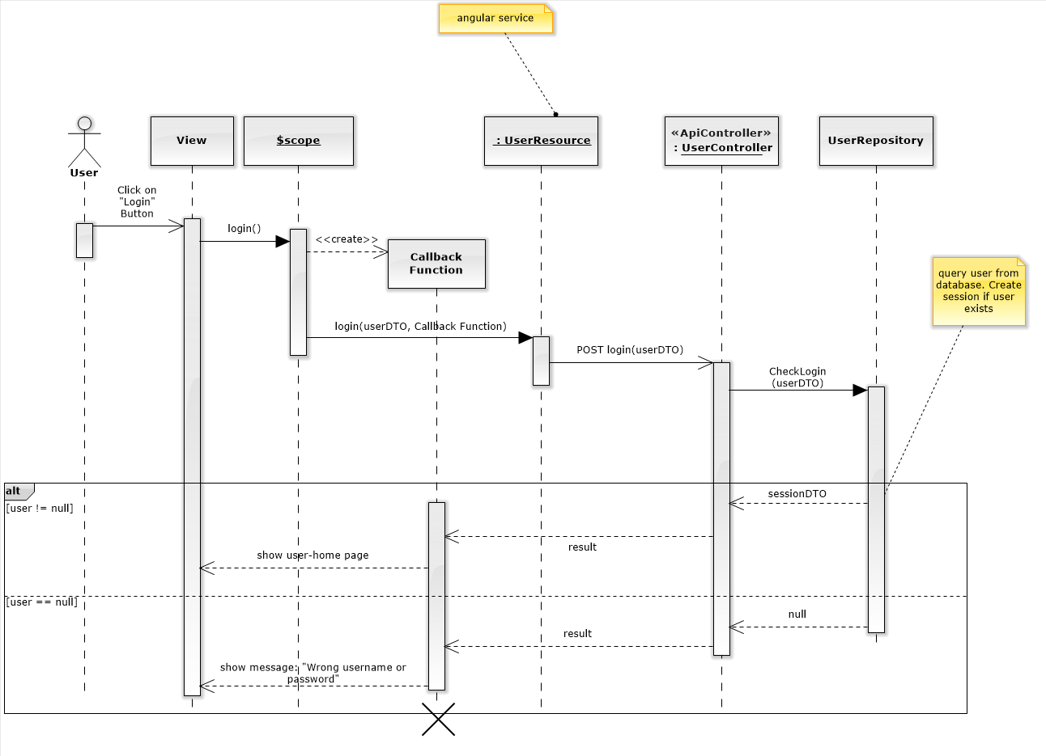

Figure 8 - Login Sequence Diagram

### Server Authorize

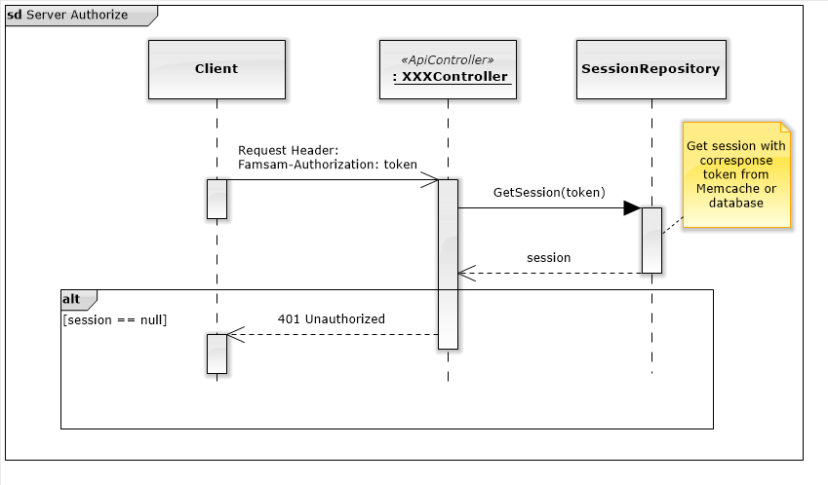

Figure 9 - Server Authorize Sequence Diagram

### Create Story

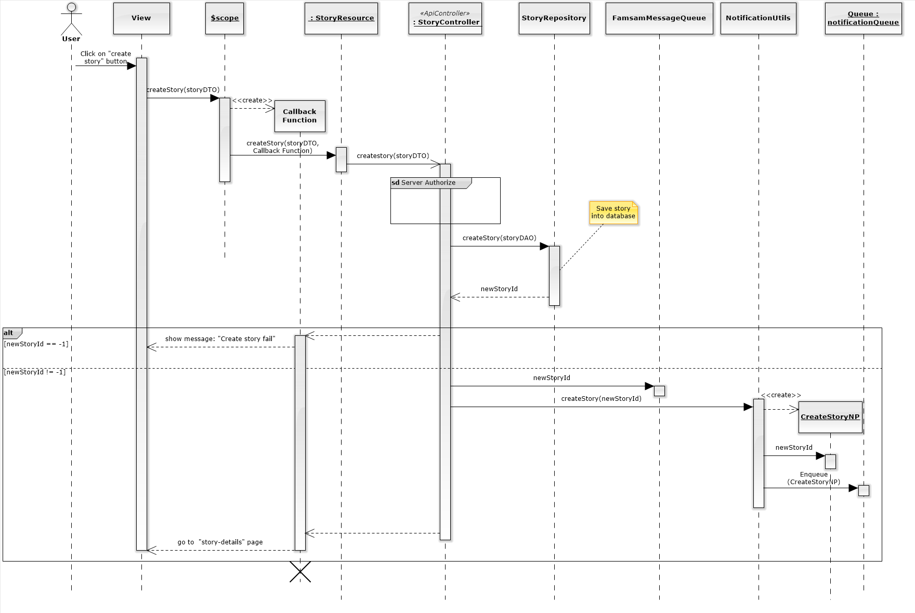

Figure 10 - Create Story Sequence Diagram

### Invite a Person to Family

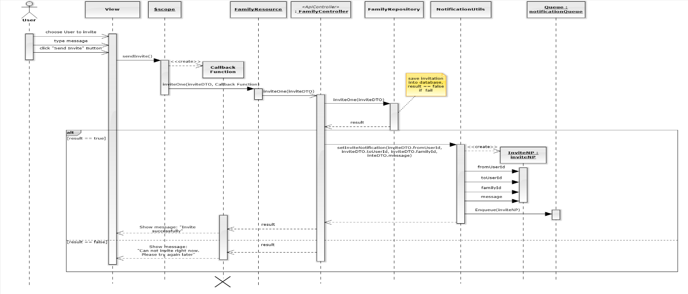

Figure 11 - Invite a Person to Family Sequence Diagram

### Upload Photo

1. Select Photo

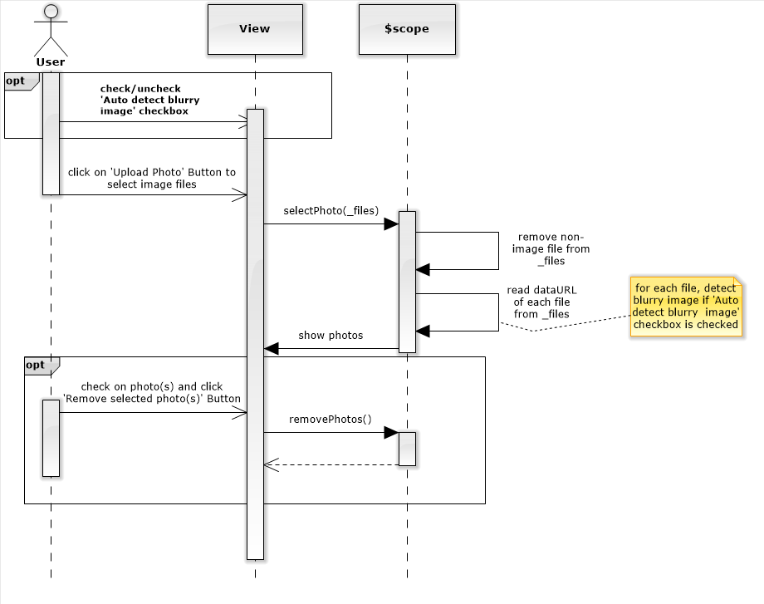

Figure 12 - Select Photo Sequence Diagram

1. Upload selected photos

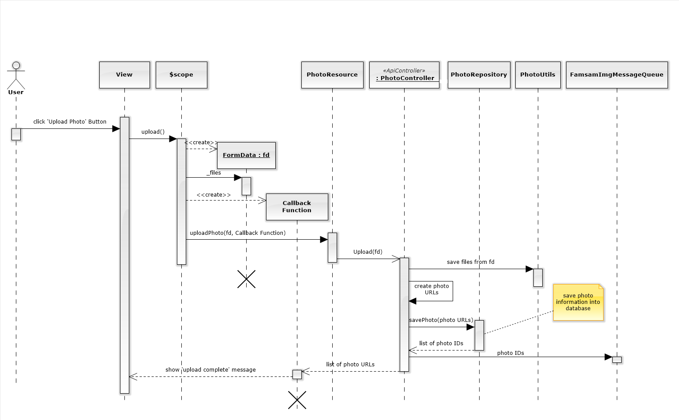

Figure 13 - Upload Selected Photos Sequence Diagram

### Sharing

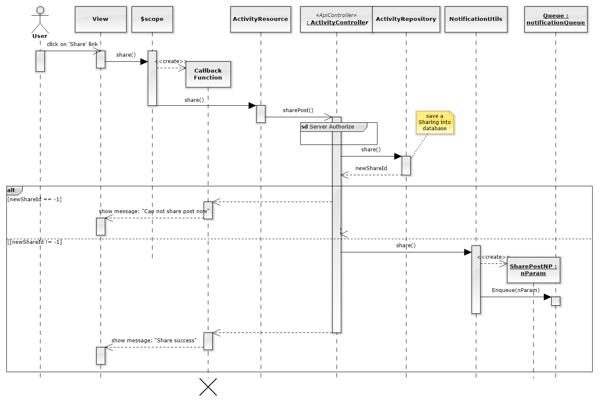

Figure 14 - Sharing a story or an album (a post)

### Create Thumbnail Image

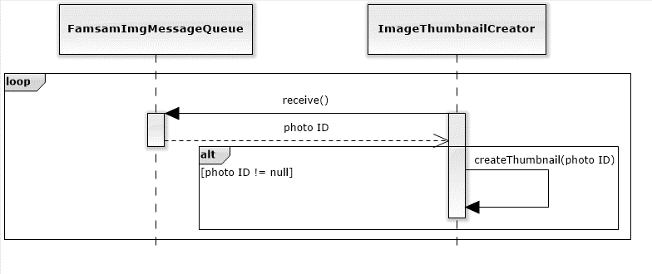

Figure 15 - Create Thumbnail Image Sequence Diagram

### Notification

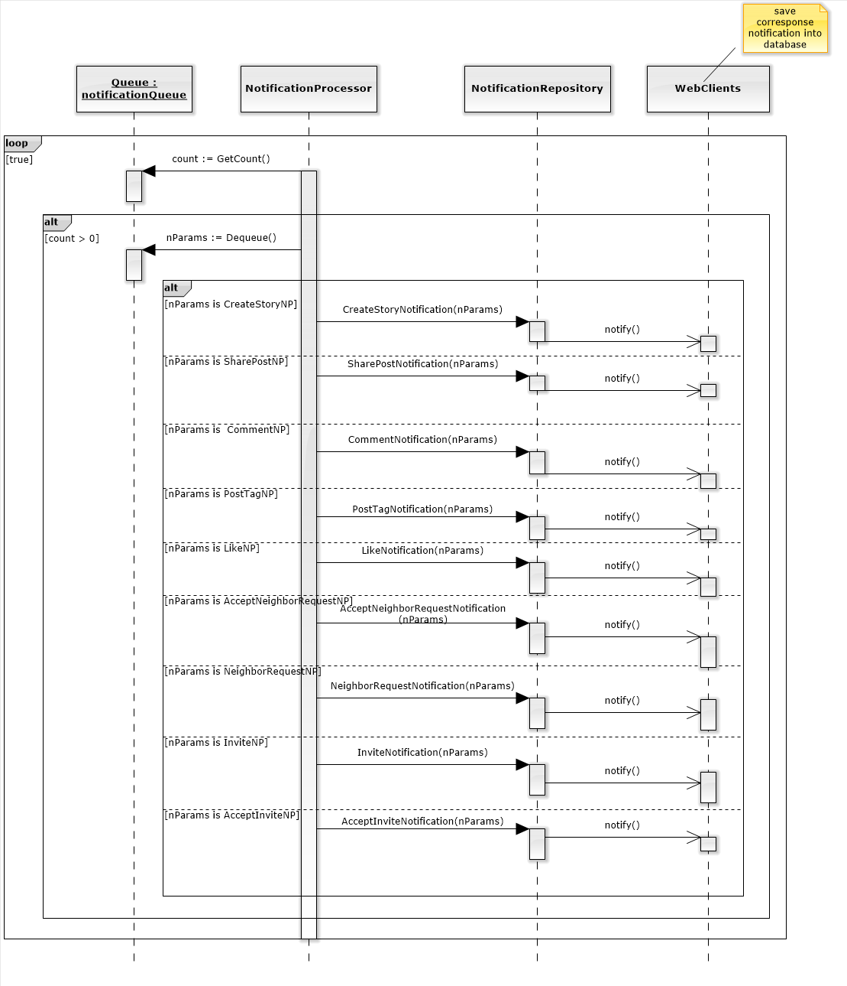

Figure 16 - Notification Sequence Diagram

### Calculate TF values

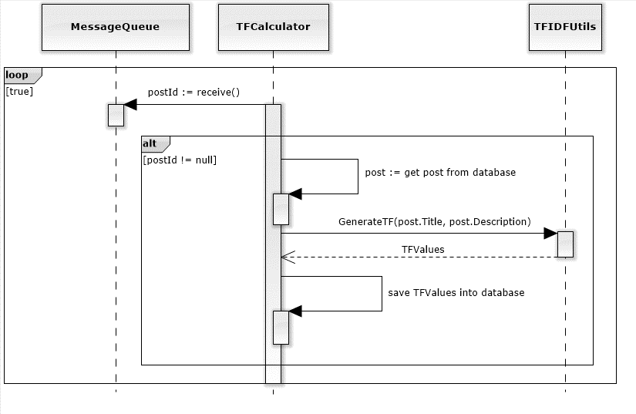

Figure 17 - Generate TF values sequence diagram

### Recommend

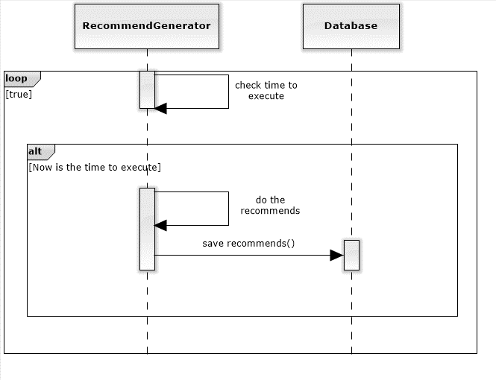

Figure 18 - Periodic Recommendation Sequence Diagram

## User Interface Design

### Login (Sign in) Screen

* 1. Screen Images

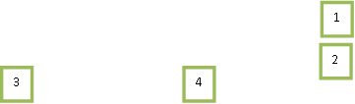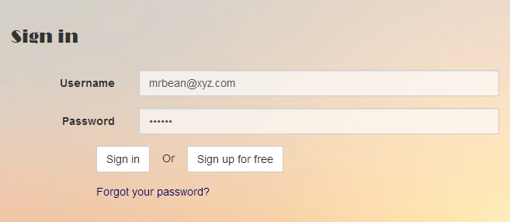

Figure 19 - Sign in Screen

* 1. Objects and Actions

Data Fields

|  |  |  |  |  |  |  |
| --- | --- | --- | --- | --- | --- | --- |
| **Field No** | **Field name** | **Type** | **Mandatory** | **Data type** | **Max length** | **Description** |
| 1 | Username | text | Y | nvarchar | 255 | User email to login |
| 2 | Password | password | Y | nvarchar | 255 | Password to login |

Data Actions

|  |  |  |  |  |  |
| --- | --- | --- | --- | --- | --- |
| **Field No** | **Field name** | **Type** | **Action** | **Description** | **Validation** |
| 3 | Sign in | Button | On click | Sign in (login) |  |
| 4 | Sign up for free | Button | On click | Go to register (sign up) page |  |

### Register (Sign up) Screen

1. Screen Images

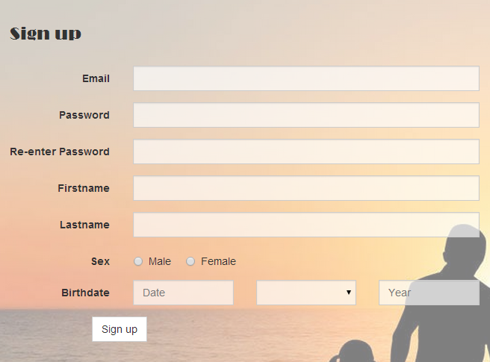

1

2

3

4

5

6

7

8

9

10

Figure 20 - Sign up Screen

1. Objects and Actions

Data Fields

|  |  |  |  |  |  |  |
| --- | --- | --- | --- | --- | --- | --- |
| **Field No** | **Field name** | **Type** | **Mandatory** | **Data type** | **Max length** | **Description** |
| 1 | Email | text | Y | nvarchar | 255 | User email to sign up |
| 2 | Password | password | Y | nvarchar | 255 | Password to sign up |
| 3 | Re-enter Password | password | Y | nvarchar | 255 | Confirm password to login |
| 4 | Firstname | text | Y | nvarchar | - | First name of user |
| 5 | Lastname | text | Y | nvarchar | - | Last name of user |
| 6 | Sex | radio | Y | bit | - | Indicate wheather user is male or female. |
| 7 | Birthday | number | Y | int | - | Day of birth of user |
| 8 | Birthmonth | number | Y | int | - | Month of birth of user |
| 9 | Birthyear | number | Y | int | - | Year of birth of user |

Data Actions

|  |  |  |  |  |  |
| --- | --- | --- | --- | --- | --- |
| **Field No** | **Field name** | **Type** | **Action** | **Description** | **Validation** |
| 10 | Sign up | Button | On click | Sign up (register) |  |

### Homepage Screen

1. Screen Images

3

2

1

4

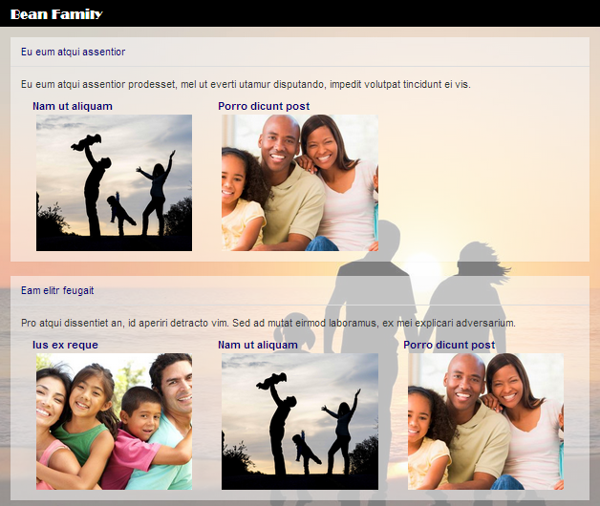

Figure 21 - Homepage Screen

1. Objects and Actions

Data Fields

(n/a)

Data Actions

|  |  |  |  |  |  |
| --- | --- | --- | --- | --- | --- |
| **Field No** | **Field name** | **Type** | **Action** | **Description** | **Validation** |
| 1 | Family Name | link | On click | Forward to family home page | - |
| 2 | Story Name | link | On click | Forward to story details page | - |
| 3 | Album Title | link | On click | Forward to album details page | - |
| 4 | Album Image | image | On click | Forward to album details page | - |

### User Personal Info Screen

1. Screen Images

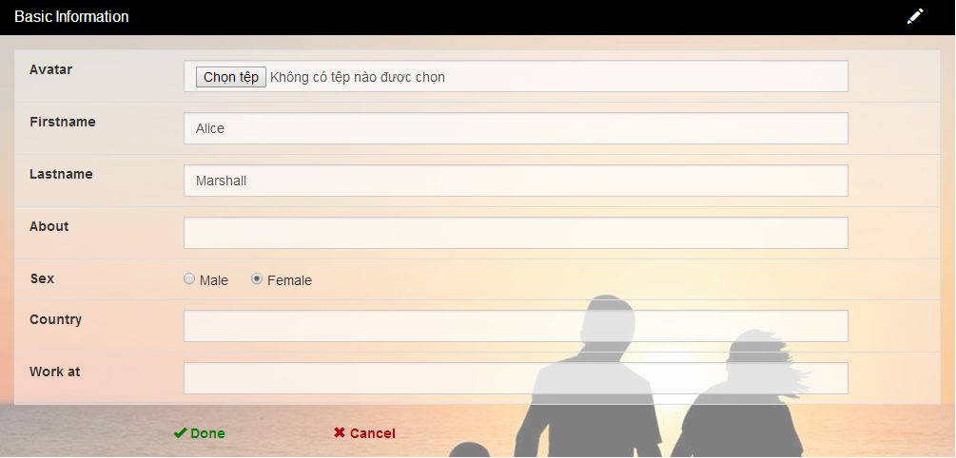

1

2

3

4

5

6

7

8

9

10

11

12

13

14

15, 16

17

18

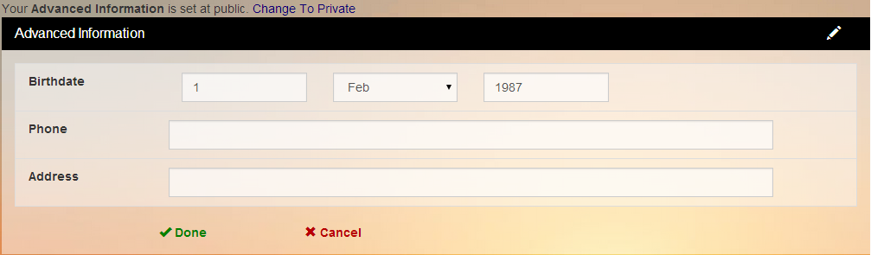

Figure 22 - User personal Information Screen

1. Objects and Actions

Data fields

|  |  |  |  |  |  |  |
| --- | --- | --- | --- | --- | --- | --- |
| **Field No** | **Field name** | **Type** | **Mandatory** | **Data type** | **Max length** | **Description** |
| 1 | Avatar | file | N | file | - | Avatar of user |
| 2 | Firstname | text | Y | nvarchar | 255 | First name of user |
| 3 | Lastname | text | Y | nvarchar | 255 | Last name of user |
| 4 | About | text | N | nvarchar | - | Description about user |
| 5 | Sex | checkbox | Y | bit | - | Indicate whether user is male or female. |
| 6 | Country | text | N | nvarchar | 20 | Country of user |
| 7 | Work at | text | N | nvarchar | 20 | Company’s name of user |
| 8 | Birthday | number | Y | int | - | Day of birth of user |
| 9 | Birthmonth | select | Y | int | - | Day of month of user |
| 10 | Birthyear | number | Y | int | - | Day of month of user |
| 11 | Phone | text | N | nvarchar | 20 | Phone number of user |
| 12 | Address | text | N | nvarchar | 255 | Address of user |

Data Actions

|  |  |  |  |  |  |
| --- | --- | --- | --- | --- | --- |
| **Field No** | **Field name** | **Type** | **Action** | **Description** | **Validation** |
| 13 | Done basic info | button | On click | Submit basic info data to server | Inputted data must be valid |
| 14 | Cancel basic info | button | On click | Cancel edit basic info |  |
| 15 | Change To Private | link | On click | Submit private privacy of user’s advance info to server |  |
| 16 | Change To Public | link | On click | Submit public privacy of user’s advance info to server |  |
| 17 | Done Advance information | button | On click | Submit advance info data to server | Inputted data must be valid |
| 18 | Cancel basic info | button | On click | Cancel edit basic info |  |

### Family Home Screen

1. Screen Images

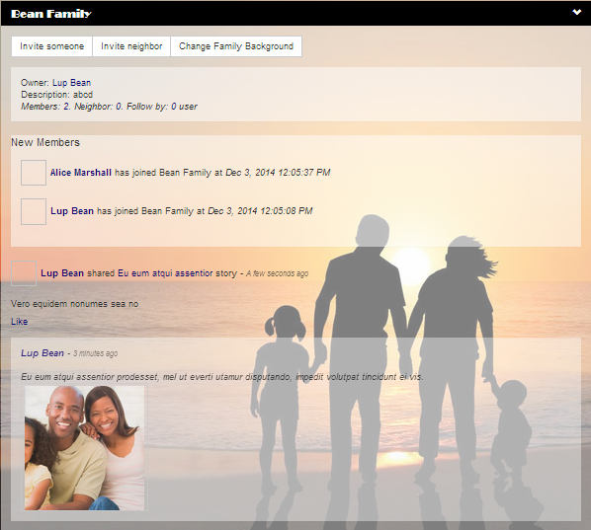

1

2

3

4

4

5

6

5

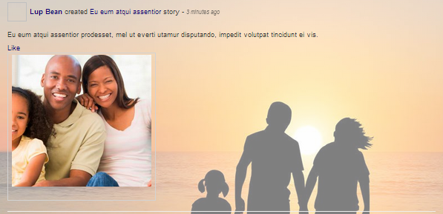

Figure 23 - Family Homepage Screen

1. Object and Actions

Data fields

N/A

Data actions

|  |  |  |  |  |  |
| --- | --- | --- | --- | --- | --- |
| **Field No** | **Field name** | **Type** | **Action** | **Description** | **Validation** |
| 1 | Invite Someone | Button | On click | Open ‘invite someone to family’ pop-up | - |
| 2 | Invite Neighbor | Button | On click | Open ‘invite neighbor’ pop-up | - |
| 3 | Change family background | Button | On click | To chang family background | - |
| 4 | User’s name | Link | On Click | forward to user’s personal info | - |
| 5 | Post title | Link | On click | forward to post (story/album) details page | - |
| 6 | Like | Link | On click | like the post (story/album) |  |

### Create Story Screen

1. Screen Images

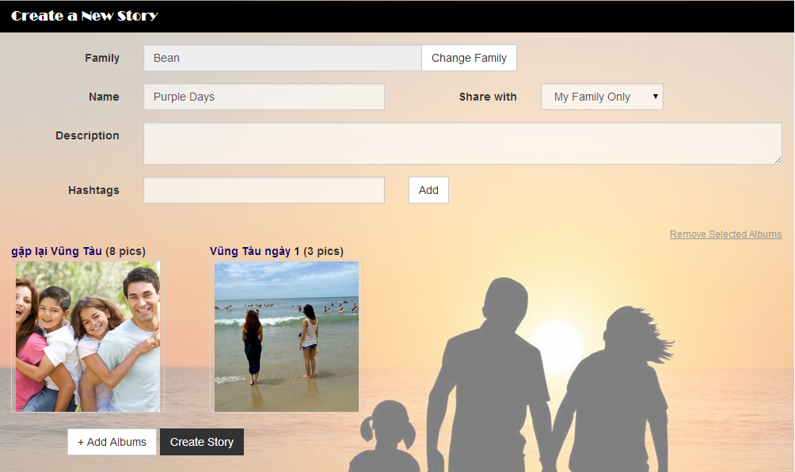

11

10

7

9

8

6

5

4

3

2

1

Figure 24 - Create Story Screen

1. Object and Actions

Data Fields

|  |  |  |  |  |  |  |
| --- | --- | --- | --- | --- | --- | --- |
| **Field No** | **Field name** | **Type** | **Mandatory** | **Data type** | **Max length** | **Description** |
| 1 | Family Name | Text | Y | nvarchar | 20 | Family Name of the story |
| 3 | Story Name | Text | Y | nvarchar | 20 | Name (Title) of the story |
| 4 | Share with | Select | Y | nvarchar | 10 | Privacy of the story |
| 5 | Description | Text | N | nvarchar | 255 | Description of the story |
| 6 | HashTag | Text | N | nvarchar | 100 | Hash tag of the story |

Data Actions

|  |  |  |  |  |  |
| --- | --- | --- | --- | --- | --- |
| **Field No** | **Field name** | **Type** | **Action** | **Description** | **Validation** |
| 2 | Change Family | Button | On click | Show pop-up to choose story’s family | - |
| 7 | Add HashTag | Button | On click | Add typed hashtag into current story | - |
| 8 | Add Albums | Button | On click | Show pop-up to choose or create album | - |
| 9 | Create Story | Button | On click | Create Story | - |
| 10 | Remove selected albums | Link | On click | Remove selected album | - |
| 11 | Select album | Image | On click | Click to select album | - |

### Create Album Screen

1. Screen Images

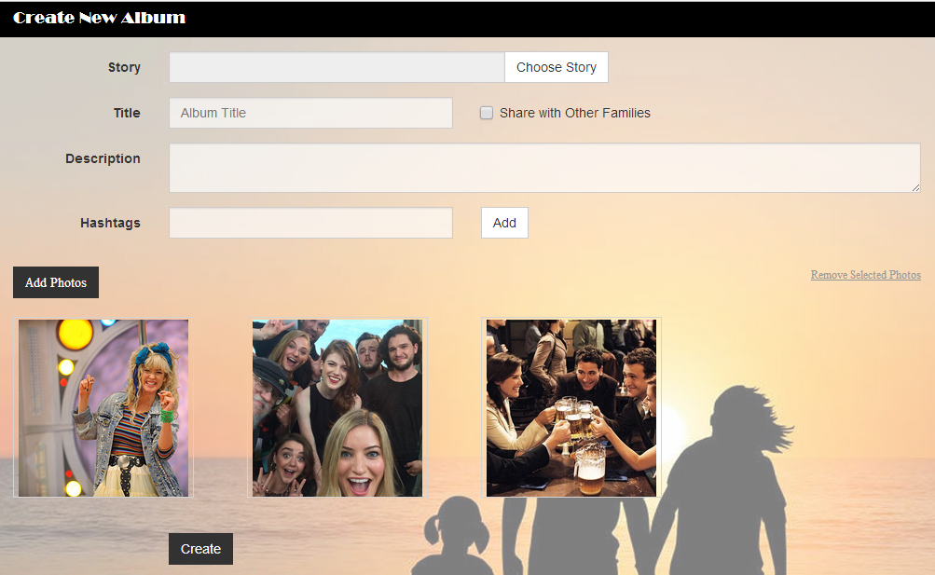

11

10

9

8

7

6

5

4

2

1

3

1. Object and Actions

Data Fields

|  |  |  |  |  |  |  |
| --- | --- | --- | --- | --- | --- | --- |
| **Field No** | **Field name** | **Type** | **Mandatory** | **Data type** | **Max length** | **Description** |
| 1 | Story name | Text | N | nvarchar | 20 | Story name which contains the album |
| 3 | Album Title | Text | Y | nvarchar | 20 | Title of the album |
| 5 | Description | Text | N | nvarchar | 255 | Description of the album |
| 6 | HashTag | Text | N | nvarchar | 100 | Hash tag of the story |

Data Actions

|  |  |  |  |  |  |
| --- | --- | --- | --- | --- | --- |
| **Field No** | **Field name** | **Type** | **Action** | **Description** | **Validation** |
| 2 | Choose Story | Button | On click | Show pop-up to choose story for the album | - |
| 4 | Share with other families | Checkbox | On click | Indicate whether the album is shared with other families or not | - |
| 7 | Add HashTag | Button | On click | Add typed hashtag into current album | - |
| 8 | Add Photo | Button | On click | Show pop-up to upload photo | - |
| 9 | Remove selected photos | Link | On click | Remove selected photos | - |
| 10 | Select photo | Image | On click | Click to select photo | - |
| 11 | Create | Button | On click | Submit form to create album | - |

### Upload Photo Screen

1. Screen Images

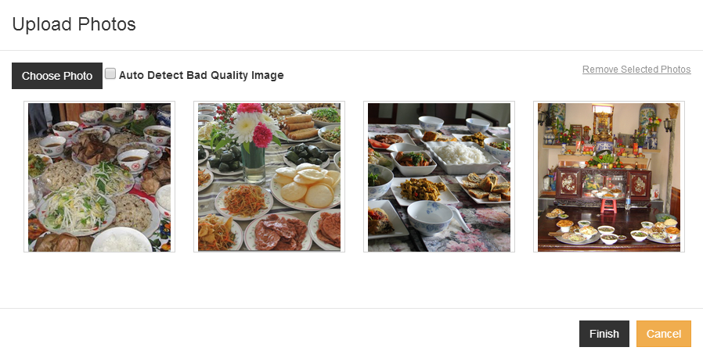

1. Object and Actions

Data Fields

Data Actions

### Story Detail Screen

1. Screen Images

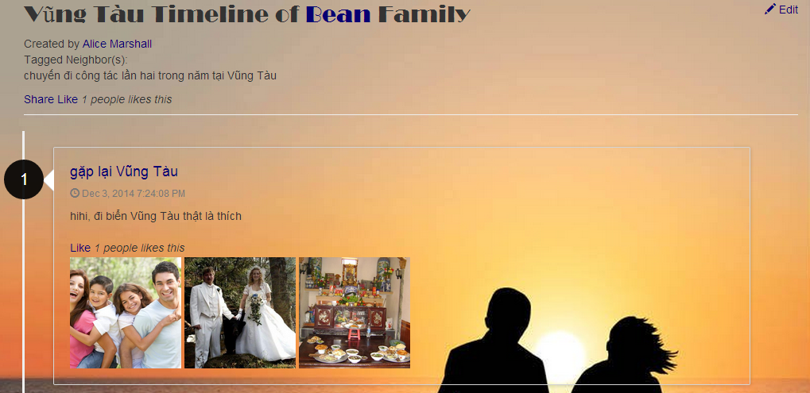

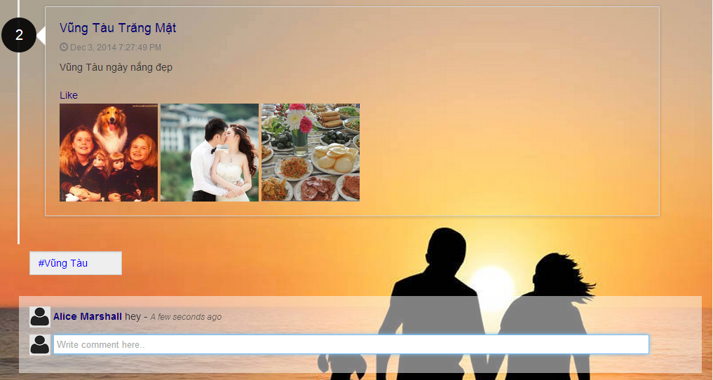

1. Object and Actions

### Photo Detail Screen

1. Screen Images

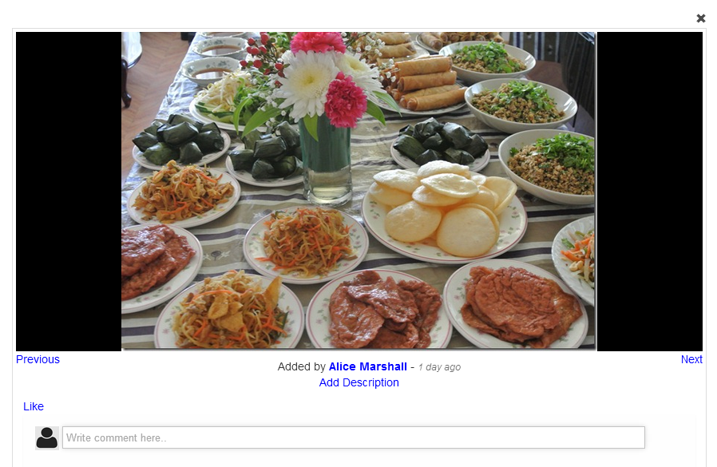

1. Object and Actions